VISVESVARAYA TECHNOLOGICAL UNIVERSITY
BELAGAVI


Project Work Report on

AI VOGUE
Submitted by

Hemanth Harishetty | 2JR21CS036
Rahul Kulkarni | 2JR21CS063
Sakshi Shivapujimath | 2JR22CS075
Soumya Halki | 2JR22CS105

In partial fulfillment of the requirement for the award of the
Bachelor of Engineering
In
Computer Science & Engineering

Under the Guidance of
Prof. Priyanka Desurkar
Asst. Professor

Subject Code: BCS786


Jain College of Engineering & Research, Belagavi

Department of Computer Science & Engineering
Academic Year 2025 - 2026
Jain College of Engineering & Research, Belagavi
(Approved by AICTE , New Delhi ,Affiliated to VTU Belagavi & Recognized by Govt. of Karnataka)

Department of Computer Science & Engineering

CERTIFICATE

This is to certify that the report on “AI VOGUE” is a bonafied work carried out by Hemanth Harishetty(2JR22CS036), Rahul Kulkarni(2JR22CS063), Sakshi Shivapujimath(2JR22CS075) Soumya Halki(2JR22CS105) in partial fulfilment of VII semester, to award the degree in Computer Science & Engineering of the Visvesvaraya Technological University, It is witnessed that all corrections/suggestions indicated have been incorporated in the report. The report has been approved as it satisfies all the academic requirements in respect of report as prescribed for the degree in engineering

Guide | HOD | Principal
(Prof.Priyanka Desurkar) | (Dr. Pritam Dhumale) | (Dr. S. V Gorabal)

Acknowledgement

The satisfaction that accompanies the successful completion of any task would be incomplete without the mention of people who made it possible and whose constant guidance and encouragement crowned our efforts with success. We consider our privilege to express the voice of gratitude and respect to all those who guided us and inspired us in completion of this project. First and foremost, we ought to pay due regards to our renowned institution, which provided us a platform and an opportunity for carrying out this project work.

Our sincere gratitude to our beloved Principal Dr. S. V. Gorabal, for providing an ideal atmosphere to pursue my objectives under his able administration.

We are also thankful to Dr. Virupaxi B. Dalal, Dean Academics, who has given valuable suggestions during the work along with his moral support and encouragement. We are thankful to Dr. Pritam Dhumale, HOD, Dept. of Computer Science & Engineering, for motivating us and also allowing us to use the facilities of the department to complete this Project Work .

We express our sincere thanks to Prof. Abhilasha J. and Prof. Sukhada Inamdar., Project Coordinator for having supported the work related to this Project. Their contributions and technical support in preparing this report are greatly acknowledged. We express our sincere thanks to our guide Prof. Priyanka Desurkar, designation, Dept. of Computer Science & Engineering for their constant co-operation, support, and valuable suggestions. We would like to thank our parents for their constant moral support throughout the completion of this Project Work. Finally, last but not the least, we would like to extend our deep sense of gratitude to our friends who always inspired us and encouraged us throughout the completion of this Project Work.

1.Hemanth Harashetty

2.Rahul Kulkarni

3.Sakshi Shivapujimath

4.Soumya Halki

iii

ABSTRACT

AI VOGUE is an advanced online fashion platform designed to address the common challenges faced by users while shopping for clothing online, such as uncertainty about size, fit, length, and overall style, which often leads to dissatisfaction, wasted money, and high product return rates. Traditional online shopping platforms rely on standard product images and generic models, which do not reflect the diverse body shapes of real users, and confusing size charts further complicate purchase decisions. Moreover, affordable and sustainable fashion options, including rental clothing and curated thrift items, are scattered across multiple platforms, making it difficult for users to access them conveniently. AI VOGUE overcomes these issues by providing a comprehensive, user-friendly solution through a 2D avatar system that allows users to upload a photo and instantly see how different outfits would look on their own body shape, without requiring heavy 3D rendering. The platform integrates AI-powered outfit recommendations that consider body type, style preferences, and occasion, AR-style virtual try-ons, rental clothing options, and a curated thrift store featuring affordable pre-loved items. In addition, a built-in virtual fashion advisor chatbot offers instant styling guidance, helping users make confident and personalized fashion choices. By combining these features, AI VOGUE not only reduces the risk of wrong purchases and enhances user confidence in online shopping but also promotes sustainable fashion practices, provides quick and convenient outfit suggestions, and delivers a seamless, personalized, and inclusive shopping experience even for users with low-end devices.

Keywords: Clothing Rental, Thrift Clothing, 2D Avatar ,AI-based Outfit Recommendation, t shirt printing

 |  |  |  | CONTENTS
Abstract |  |  |  |  | i
Declaration |  |  |  |  | ii
Acknowledgement |  |  |  |  | iii
List of Figures |  |  |  |  | vi
Chapter -1 |  |  |  | Introduction | 1-4
1.1 |  |  |  | Overview
1.2 |  |  |  | Significance
1.3 |  |  |  | Motivation
1.4 |  |  |  | Deep Learning
1.5 |  |  |  | Basic Process
Chapter -2 |  |  |  | Literature Survey | 5-7
Chapter -3 |  |  |  | Problem Definition | 8-11
3.1 |  |  |  | Problem Statement
3.2 |  |  |  | Objectives
3.3 |  |  |  | Key Components
3.4 |  |  |  | Features
3.5 |  |  |  | Advantages
Chapter -4 |  |  |  | System Design | 12-19
4.1 |  |  |  | AI Vogue Architecture
4.2 |  |  |  | Use Case Diagram
4.3 |  |  |  | Activity Diagram
 |  | 4.3.1 |  | AI Vogue Imange Recognition
 |  | 4.3.2 |  | AI vogue usecases
 |  | 4.3.3 |  | AI Results
4.4 |  |  |  | Flow Chart
Chapter -5 |  |  |  | Requirements | 20-24
5.1 |  |  |  | Hardware Requirements
5.2 |  |  |  | Software Requirements
5.2.1 |  |  |  | Operating System
5.2.2 |  |  |  | Python
5.3 |  |  |  | Functional Requirements
5.4 |  |  |  | Non- Functional Requirements
5.5 |  |  |  | Libraries and Modules
 | 5.5.1 |  |  | Frontend Libraries/Module
 | 5.5.2 |  |  | Database Modules
 | 5.5.3 |  |  | Backend Framework
Chapter -6 |  |  |  | Implementation | 25-27
6.1 |  |  |  | Implementation
6.2 |  |  |  | Project Overview
Chapter -7 |  |  |  | Testing | 28-29
7.1 |  |  |  | Functionality Testing
Chapter -8 |  |  |  | Results | 30-33
8.1 |  |  |  | AI VOGUE Side Navigation Menu
8.2 |  |  |  | AI VOGUE to Explore Fashion
8.3 |  |  |  | AI VOGUE Collections
8.4 |  |  |  | AI VOGUE Men’s Vintage
8.5 |  |  |  | AI VOGUE Shirt Print
8.6 |  |  |  | Thrift Store
8.6.1 |  |  |  | Pants Collections
8.7 |  |  |  | Revibe
8.7.1 |  |  |  | Revibe Collections
8.7.2 |  |  |  | Custom Design
8.8 |  |  |  | AI Prism
8.8.1 |  |  |  | Profile page
Chapter -9 |  |  |  | Conclusion | 48
References |  |  |  |  | 49

List of Figures

Figure Caption Page
No.
4.1 AI vogue Design Diagram 13
4.2 Usecase Diagram of AI VOGUE 15
4.3 Activity Diagram of the AI VOGUE 16
4.3.1 AI VOGUE
Image Recognition 16
4.3.2 AI VOGUE results 17
4.4 Flow Chart 18
8.1 AI VOGUE with sside navigation menu 30
8.2 AI VOGUE to Explore Fashion 31
8.3 AI VOGUE Collections 31
8.4 AI VOGUE Men’s Vintage 32
8.5 AI VOGUE Shirt Print 33
8.6 Thrift Store 43
8.6.1 Pants Collections 44
8.7 Revibe 45
8.7.2 Revibe Collections 46
8.7.3 Custom Design 47
8.8 AI Prism 48
8.8.1 Profile Page 49

Chapter 1
Introduction

Overview

AI VOGUE is a comprehensive and innovative online fashion platform designed to revolutionize the way users shop for clothing digitally. Traditional online shopping platforms often fail to provide an accurate representation of how clothes will look on different body types, relying on standard product images and generic models that do not reflect real users’ shapes and proportions. This limitation creates uncertainty regarding size, fit, length, and overall style, which often leads to dissatisfaction, wasted money, and high return rates. AI VOGUE addresses these issues by incorporating a 2D avatar system that allows users to upload a photo and generate a realistic avatar representing their body shape. This avatar acts as a virtual fitting tool, enabling users to preview outfits accurately without requiring heavy 3D modeling.

The platform further enhances the shopping experience by integrating AI-based outfit recommendations, curated rental clothing options, a thrift store with affordable pre-loved items, and a virtual fashion advisor chatbot. AI algorithms analyze the user’s body shape, style preferences, and the occasion to provide personalized suggestions, making fashion choices easier and more reliable. The inclusion of AR-style virtual try-on features allows users to see how clothes fit in real-time, while rental and thrift options promote sustainable and eco-friendly fashion practices. AI VOGUE thus combines convenience, personalization, and sustainability, providing a seamless, inclusive, and interactive fashion shopping experience for users of all ages and device capabilities.

1.2 Significance
The significance of AI VOGUE lies in its ability to transform the online fashion shopping experience by addressing the key challenges faced by users. Traditional online shopping often leaves customers uncertain about the size, fit, and overall appearance of clothing, as product images are shown on generic models that rarely reflect real body shapes, leading to dissatisfaction, wasted money, and high product return rates. AI VOGUE overcomes these issues through a personalized 2D avatar system, allowing users to visualize how clothes will look and fit on their own body, thereby increasing confidence in purchase decisions. In addition to enhancing shopping accuracy, AI VOGUE promotes sustainable fashion practices by integrating rental clothing options and a curated thrift store for pre-loved items, encouraging eco-friendly shopping, reducing unnecessary consumption, and providing convenient access to affordable fashion in a single platform. The platform also ensures inclusivity by accommodating diverse body types, style preferences, and budgets, while AI-powered outfit recommendations and a virtual fashion advisor chatbot offer instant styling guidance, color coordination tips, and complementary item pairing, making fashion shopping easier, faster, and more enjoyable. Overall, AI VOGUE bridges the gap between traditional online shopping limitations and modern user expectations by delivering a seamless, interactive, and eco-conscious shopping experience that reduces errors, enhances user satisfaction, and supports sustainable, informed fashion choices even for users with low-end devices, combining technology, personalization, and sustainability to set a new standard for online fashion platforms.

1.3 Motivation
The motivation behind AI VOGUE arises from the need to create a more personalized, convenient, and sustainable online fashion shopping experience. Online shoppers often face confusion when selecting clothes due to unclear size charts, generic model images, and scattered access to affordable or eco-friendly fashion options. Many users also seek guidance on what to wear for specific occasions or which styles and colors suit them best, but such personalized advice is rarely available on standard e-commerce platforms. AI VOGUE was developed to address these challenges by combining AI technology, a 2D avatar system, and curated rental and thrift options into a single platform. This approach allows users to preview outfits accurately, receive instant AI-based style recommendations, and explore sustainable fashion choices conveniently. By making fashion shopping interactive, inclusive, and eco-conscious, AI VOGUE empowers users to make confident, informed, and enjoyable style decisions while saving time and reducing the stress associated with online clothing purchases.

1.4 Technologies used

4. In the “Results / Output” section
“The Deep Learning model achieved XX% accuracy in classifying the uploaded garment images.”

5. In the “Conclusion / Future Work” section
- Improve real-time detection for AI fashion based platforms.
- Train on larger datasets to store the data of Clothes.

1.5 Basic Process

1. 2D Avatar
- Generates a realistic 2D version of the user’s body from a photo, allowing virtual try-ons of clothes. It helps users see how outfits will fit and look on their own body
- It helps users see how outfits will fit and look on their own body.

2. Rental Clothing
- Provides access to clothing rentals for special occasions, making it convenient and cost-effective to try new styles without permanent purchase.

3. Thrift Store
- Offers affordable pre-loved items in a single platform, promoting sustainable fashion and reducing waste while providing budget-friendly options
4. Virtual Fashion Advisor Chatbot
- Offers instant styling guidance, answers fashion queries, suggests colors, and recommends complementary items to complete outfits.
5. AR Virtual Try-On
- Allows users to see how clothes fit and look on their 2D avatar in real-time, helping t them check size, style, and appearance, reducing purchase errors.

6. T-Shirt Printing
- Lets users customize T-shirts with their own designs, text, or graphics and preview them on their avatar before ordering, enabling personalized fashion.
.
Chapter 2

Literature Survey

[1] M. Zhou, R. Hyder, Z. Xuan, and G. Qi, “Ultravatar: A realistic animatable 3d avatar diffusion model with authenticity guided textures,” in Proceedings of the IEEE/CVF Conference on Computer Vision and Pattern Recognition, pp. 1238–1248, 2024.

[2] X. Liu, Y.-W. Tai, and C.-K. Tang, “Multimodal generation of animatable 3d human models with avatarforge,” arXiv preprint arXiv:2503.08165, 2025.

[3] I. I. Agbanu, A. B. Mohammed, and O. R. Inikpi, “Effect of ai driven personalization on purchasing decisions and customer satisfaction in the fashion industry in nigeria,” Journal homepage: https://gjrpublication. com/gjrbm, vol. 4, no. 05, 2024.

[4] A. S. Verma, “The role of fashion social commerce in advancing sustainable practices in india,” NIFT JOURNAL OF FASHION, p. 87, 2023.

[5] S. Xu, L. Wu, W. Liao, and S. Fujimura, “Enhancing collaborative shop ping experience through interactive personalized avatars and shared gaze in a multi-user augmented reality environment,” International Journal of Human–Computer Interaction, pp. 1–22, 2024.

[6] M. Yuan, I. R. Khan, F. Farbiz, S. Yao, A. Niswar, and M.-H. Foo, “A mixed reality virtual clothes try-on system,” IEEE Transactions on Multimedia, vol. 15, no. 8, pp. 1958–1968, 2013.

[7] R. Shiba, A. Fadel, A. Elbashaar, K. Emad, and R. Elgohary, “Expand: Animmersive virtual try-on system with augmented reality,” International Integrated Intelligent Systems, vol. 2, no. 1, 2025.

[8] M. A. Raji, H. B. Olodo, T. T. Oke, W. A. Addy, O. C. Ofodile, and A. T. Oyewole, “E-commerce and consumer behavior: A review of ai-powered personalization and market trends. gsc advanced research and reviews, 18 (3), 066–077,” 2024

Chapter 3

Problem Definition
3.1 Problem Statement

Online fashion shopping has seen rapid growth over the past few years, but it still presents several critical challenges that negatively affect the user experience. One of the primary problems is the inability of traditional online platforms to accurately represent how clothing will look on diverse body types. Most e-commerce websites display products on standard models whose body shapes, sizes, and proportions rarely match those of real users. As a result, shoppers struggle to determine whether the size, fit, length, or overall style of an outfit will suit them personally. This creates significant uncertainty in purchase decisions, leading to hesitation, frustration, and often incorrect choices.

Another major issue is the high rate of product returns and dissatisfaction. Because users cannot physically try on clothes, many end up ordering items that do not fit well or do not match their expectations, wasting both time and money. This not only affects consumers but also increases operational costs for retailers and contributes to environmental concerns due to the logistics of handling returns.

In addition to fitting and sizing challenges, users face difficulty in finding affordable and sustainable fashion options. Many individuals are interested in renting clothing for special occasions or purchasing high-quality thrift items, but these options are spread across multiple platforms. This fragmentation makes it inconvenient and time-consuming for users to access eco-friendly or cost-effective fashion solutions in a single place.
3.2 Objective
- smart fashion platform that recommends thrift, rental, and new fashion items using AI-based suggestions. AI Vogue aims to build an intelligent fashion website where users can explore clothing items from thrift stores, rental stores, and new collections. The platform uses AI to show the most suitable products based on a user’s style and interests.
- users to explore trendy outfits based on their preferences, budget, and body measurements This objective focuses on helping users easily discover fashionable and up-to-date clothing on the AI Vogue platform. The system analyzes each user’s preferences — such as style, size, color choices, and budget — and displays outfits that match their personal taste. Instead of manually searching through hundreds of items, users can instantly see clothing that suits their personality and current trends.
- To build a 2D/3D avatar system where users can visualize how clothes will look on a virtual model. This objective aims to create a virtual try-on feature that allows users to see how different outfits will look on a digital avatar. The system generates a 2D or 3D model based on the user’s body measurements, height, and preferences. Users can apply any clothing item—such as shirts, dresses, pants, or accessories—directly onto the avatar to preview the fit, style, and overall appearance.
- To promote sustainable fashion by encouraging thrift and rental options. This objective focuses on creating a virtual avatar feature that lets users see how clothes will look on a digital model. The system uses a 2D or 3D avatar that represents the user’s body shape and measurements. When a user selects an outfit, it is displayed on the avatar so they can preview the style, fit, and overall appearance before buying. This helps users make confident shopping decisions and gives them a realistic virtual try-on experience.
- To automate notifications for customers and sellers when an order is placed, shipped, or delivered. This objective aims to build an automated notification system that keeps both customers and sellers informed throughout the order process. When a customer places an order, the system immediately sends notifications confirming the purchase. As the order moves through different stages—such as shipping, transit, and delivery—the platform automatically updates both the buyer and the seller through messages, emails, or in-app alerts.
- To provide accurate product predictions using AI/ML models, such as outfit matching, color combinations, and style suggestions. This objective focuses on using Artificial Intelligence and Machine Learning to deliver highly accurate product predictions to users. The system analyzes user behavior, preferences, previous purchases, and trending fashion data to recommend the most suitable outfits. It can automatically suggest matching clothing items, ideal color combinations, and complete style sets based on the user’s taste.
7.To simplify user navigation with well-designed pages like:
  - Thrift Store
  - Rental Store
  - Avatar Overview
  - Wishlist
  - Cart
8.To create a backend workflow for:
  - Adding products
  - Managing sellers
  - Processing orders
  - Sending notifications

9.To store and analyze user behavior for improving fashion recommendations over time. This objective focuses on tracking and analyzing user behavior on the AI Vogue platform to improve fashion recommendations. The system collects data such as clicks, searches, items viewed, purchases, and wishlist activity. By analyzing this information, the platform can identify patterns and preferences for each user.
10.To integrate secure login and registration
for both users and sellers. This objective focuses on implementing a secure login and registration system for both users and sellers on the AI Vogue platform. The system ensures that every account is verified and protected, preventing unauthorized access. Users can safely create accounts, log in, and manage their profiles, while sellers can securely add and manage products.

3.3 Key Components

User Interface (UI)
- The front-end of the platform where users interact with the system.
- Includes pages like Thrift Store, Rental Store, Avatar Overview, Wishlist, and Cart.
- Designed for smooth, responsive, and user-friendly navigation using HTML, CSS, and JavaScript.
2). Product Database
- Stores all product information including images, descriptions, sizes, prices, and stock availability.
- Handles both thrift and rental items, supporting multiple sellers.
- Ensures fast access and updates to product data.
3). AI/ML Recommendation Engine
- Analyzes user behavior, preferences, and trends to provide personalized outfit suggestions.
- Suggests matching items, color combinations, and style sets using AI algorithms.
- Continuously improves recommendations over time through machine learning.
4). Avatar System (2D/3D Try-On)
- Lets users visualize clothes on a virtual model.
- Generates avatars based on user body measurements.
- Applies selected outfits to avatars for realistic previews before purchase.
5). Authentication & Security Module
- Manages secure login and registration for users and sellers.
- Protects sensitive data using encryption and validation.
- Ensures only authorized users can access account and seller functionalities.

6). Notification System
- Sends automated alerts to customers and sellers for order updates.
- Covers events like order placed, shipped, delivered, or canceled.
- Improves communication and trust in the platform.
7). Backend & Server
- Handles product management, order processing, and data storage.
- Ensures smooth workflow between front-end actions and database updates.
- Supports scalability to accommodate multiple users and vendors.
8). Analytics & User Behavior Tracking
- Collects user interaction data like clicks, views, and purchases.
- Provides insights for AI recommendation engine and business strategy.
- Helps improve personalization and overall user experience.
9). Payment & Checkout System
- Manages secure payment processing for both thrift and rental purchases.
- Ensures smooth checkout and transaction confirmation.
- Integrates with notification and order tracking systems.

3.4Features
1.Thrift Store Page
- Users can buy pre-owned fashion items.
- Product listing with images, price, description.
- Add to cart / Wishlist options.
2. Rental Store Page
- Users can rent outfits for a specific duration.
- Rental cost, availability, and booking option.
- Calendar/slot selection feature.
3. 2D Avatar Try-On System
- Users can create a 2D avatar.
- Try outfits virtually before buying/renting.
- Avatar customization (skin tone, height, size).
4. Smart Notification System
- When the user places an order → Notification goes to customer & seller.
- Notifications via WhatsApp / Email / In-app.
- Order confirmation, shipping update, delivery info.
5. User Account System
- Login / Signup.
- Profile, order history, wishlist, cart.
- Address management & payment details.
6. Shopping Cart & Wishlist
- Add/remove items easily.
- Save items for later.
- Auto-update total amount.
7. AI-based Outfit Suggestions
- Suggests best outfits based on style, color, size, trends.
- Personalized recommendations.

3.5 Advantages
- Personalized Fashion Experience
– Provides outfit suggestions, styling ideas, and wardrobe recommendations based on user preferences.
- Smart 2D Avatar Try-On
– Users can virtually try clothes on their own avatar before buying, reducing confusion and wrong size issues.
- Saves Time
– Users don’t need to browse hundreds of items; AI filters and shows the best suggestions quickly.
- Increases Seller Visibility
– Local thrift/rental sellers get highlighted on the platform, increasing their reach and sales.
- Eco-Friendly Fashion Support
– Thrift store and rental store features encourage sustainable fashion instead of fast fashion.
- Better Decision Making
– Customers can compare outfits, check fit using the avatar, and make confident buying decisions.

Chapter 4

System design

4.1 AI Vogue Architecture

AI VOGUE is an innovative fashion-based platform that brings together three major features: a Thrift Store for sustainable shopping, a Rental Store for affordable fashion access, and an advanced 2D Avatar Try-On system for virtual outfit visualization. The platform is built using a robust multi-layer architecture that separates the user interface, business logic, AI recommendation engine, and databases. This layered design ensures smooth performance, easy scalability as the user base grows, and secure data flow between all system components. By combining AI-driven recommendations with virtual try-on technology, AI VOGUE delivers a modern, convenient, and intelligent fashion experience for both customers and sellers.

1. Start
The system is designed using a multi-layered architecture to ensure modularity, scalability, and smooth interaction across all components. At the top, the User Interface Layer (Frontend) provides the visual platform where customers, sellers, and admins interact with the system through web or mobile applications. This connects to the Application Layer (Backend / API Layer), which acts as the core controller—handling business logic, processing user requests, managing data flow, and exposing APIs for all operations. Integrated within the backend is the AI/ML Recommendation Engine, responsible for personalized product suggestions, virtual try-on predictions, object detection, trend analysis, and intelligent search results. All the system’s data is safely stored and managed in the Database Layer, which includes structured collections for users, sellers, inventory, categories, reviews, and order management. Communication between buyers and sellers is supported through the Notification System, enabling real-time updates such as order status, chat alerts, restock notifications, and promotional messages. To secure the entire ecosystem, the Authentication & Security Module ensures encrypted login, role-based access control, session handling, fraud detection, and safe data transmission, protecting both user information and platform integrity.

2. Input
The System Design Diagram represents how different parts of the AI VOGUE platform connect and work together. It shows the flow of data from the user to the backend and how various internal modules handle requests.
When a user interacts with the platform—such as uploading an image or searching for a product—the request first reaches the Frontend, which sends the data to the Backend Server through APIs. The backend then coordinates with various internal modules such as the Authentication Service, AI/ML Engine, Product Service, and Payment Gateway to process the user’s request.

3.AI Vogue Frontend Flow Diagram
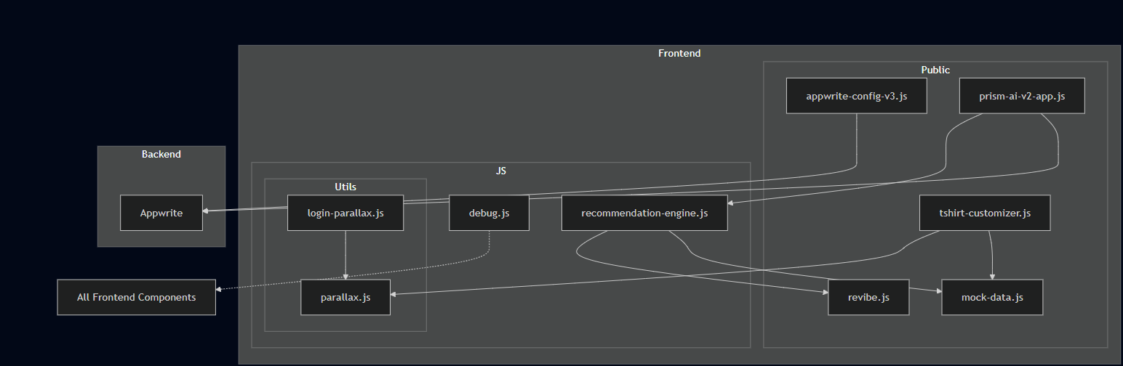

3.AI Vogue Backend Flow Diagram
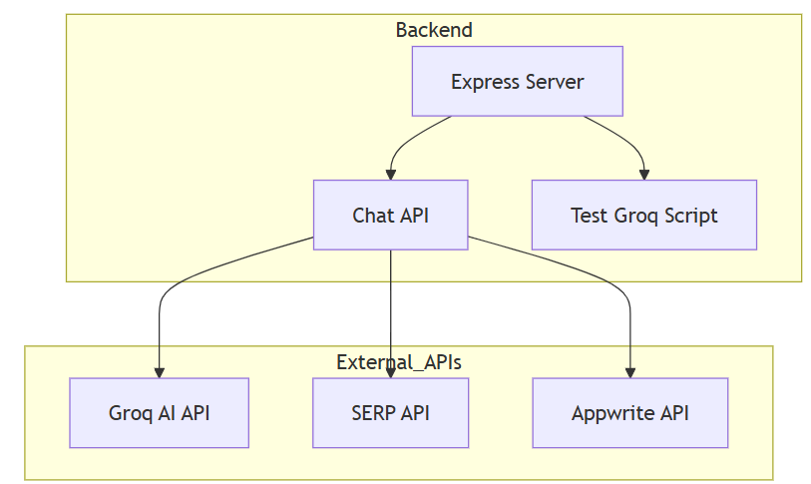

4.AI Vogue menu

AI Vogue can use object detection mainly in these cases:
1) Identifying Clothing in User-Uploaded Images
– When users upload photos, suggests items such as shirts, pants, dresses, jackets, etc.
2) Improving the 2D Avatar Try-On Feature
– Object detection helps detect body parts like the torso, legs, and shoulders so that clothes can be accurately placed and aligned on the avatar.
3) Seller Image Verification
– When sellers upload product photos, object detection checks whether the image actually contains clothing items, ensuring better image quality and preventing incorrect uploads.

5. Label Conversion
Label Conversion in AI Vogue refers to converting raw fashion-related data into meaningful labels that the system can understand.It helps classify items like tops, jeans, accessories, footwear, etc., when users or sellers upload images.This process ensures every product is tagged correctly for search, recommendations, and filtering.Label conversion also helps the 2D Avatar system map clothes to the correct body parts.It improves accuracy in object detection, product listing, and try-on features.
Overall, it makes the platform more organized, searchable, and user-friendly.

6. Feature Extraction

Once every clothing item is given a proper label (like “T-shirt”, “Jeans”, “Kurta”, “Sneakers”), the system extracts important features from the image. Once every clothing item is assigned a proper label, such as “T-shirt,” “Jeans,” “Kurta,” or “Sneakers,” the AI Vogue system proceeds to extract important features from the images. These features may include color, pattern, texture, style, shape, and other visual attributes that define the clothing item. By analyzing these details, the system can better understand the product and classify it accurately within the platform. This feature extraction is essential for enabling advanced functionalities such as outfit matching, style recommendations, and personalized suggestions, as it allows the AI to compare items, detect similarities, and generate relevant fashion advice for users.

7.STOP
The “stop” of AI Vogue refers to the final stage where all processes of the system come together and the workflow ends. At this stage, the platform completes tasks like product recommendation, avatar try-on, order processing, and seller verification. The system ensures that the correct results are delivered back to the user — such as outfit suggestions, product details, or confirmation messages. Once the required output is displayed and notifications are sent, the entire cycle resets and waits for the next user request.

Key Components
1)User Interface (Frontend)
– The screens users interact with, including Thrift Store, Rental Store, and 2D Avatar Try-On pages.
2)Backend Server (Application Layer)
– Handles all logic like login, product management, recommendations, and order processing.
3) Authentication & Security Module
– Manages user login, signup, roles, and protects data using secure methods.
4)AI/ML Recommendation Engine
– Suggests outfits, identifies preferences, and improves user experience through machine learning.
5)Object Detection Module
– Detects clothing items in images and helps align garments on the 2D avatar.
6) Product & Inventory Management System
– Stores and updates product details for thrift and rental items, including availability and categories.
7)Order & Payment Processing
– Manages cart, checkout, order tracking, rental returns, and secure payments.
8)Database Layer
– Stores user data, product listings, seller information, orders, and logs.
9)Notification System
– Sends alerts to users and sellers for orders, updates, returns, and approvals.
Use Cases
1. Personalized Outfit Recommendations
- The AI system suggests outfits based on user preferences, body type, past purchases, and trending fashion.
- Helps users discover clothing items they might like without manually browsing through hundreds of products.
2. Virtual Try-On with 2D/3D Avatar
- Users can see how clothes will look on a digital avatar resembling their body measurements.
- Reduces wrong purchases and enhances confidence in online shopping.
3. Thrift and Rental Shopping
- Users can explore pre-owned (thrift) and rental fashion items.
- Promotes sustainable fashion and provides budget-friendly alternatives.
4. Automated Notifications
- Sends real-time alerts to customers and sellers for order confirmation, shipping updates, and delivery status.
- Improves communication, transparency, and user satisfaction.
5. Secure Login and Account Management
- Provides secure registration and authentication for users and sellers.
- Protects sensitive information such as personal details, payment data, and order history.
6. Fashion Data Analysis
- Tracks user behavior, such as clicks, wishlist items, and purchases.
- Analyzes data to improve AI recommendations and personalize the shopping experience.
7. Seller Product Management
- Sellers can upload, update, and manage their products easily.
- Ensures efficient inventory control and smooth workflow for multiple vendors.

Relationships

1. User ↔ Platform (Front-end UI)
- Users interact with the website/app to browse, search, and select products.
- The platform displays recommended outfits, product details, and avatar previews.
2. User ↔ Avatar System
- Users provide body measurements or choose avatar settings.
- The avatar system shows how selected clothes will look on the virtual model.
3.User ↔ AI Recommendation Engine
- The AI analyzes user preferences, browsing history, and purchase data.
- Recommends personalized outfits, color combinations, and styles.
4.User ↔ Notification System
- Users receive automated alerts for order confirmation, shipping, and delivery updates.
5.Seller ↔ Platform
- Sellers upload, update, and manage their product listings.
- The platform maintains inventory and displays seller products to users.
6.Seller ↔ Notification System
- Sellers are notified when an order is placed, canceled, or delivered.
- Keeps sellers informed about their inventory and sales.
7.User & Seller ↔ Authentication Module
- Both users and sellers register and log in securely.
- Ensures account safety and access control for sensitive data.
8.AI Recommendation Engine ↔ Product Database
- AI fetches product features, labels, and images from the database.
- Uses this data to generate outfit suggestions and style recommendations.
9.User Behavior Tracking ↔ AI Recommendation Engine
- User interactions (clicks, searches, purchases) are analyzed to improve recommendations.

4.3 Activity Diagram
The Activity Diagram illustrates the sequence of actions and decision points involved when a user interacts with the AI VOGUE platform. It visually represents how the system behaves step-by-step, starting from the moment the user opens the application until the final output is delivered.The process begins when the user launches the application and either logs in or registers. Once authenticated, the user can upload an image of a clothing item or browse products. If an image is uploaded, the system performs preprocessing and sends the file to the AI/ML Engine, where deep learning models analyze the image, extract important features like color, pattern, and category, and generate predictions. Based on the extracted details, the system checks the product database to find matching or similar items. The matched results are then compiled and sent back to the user interface for display. If the user selects an item, they can view details, add it to the cart, or proceed with further actions such as saving to wishlist or buying. The object scan process, where the first object detection system will be run then the user directs the object to the camera. Then the object scan process will run. It visually represents how the system behaves step-by-step, starting from the moment the user opens the application until the final output is delivered.The process begins when the user launches the application and either logs in or registers.4.3.1 AI Vogue Scan
The object scan process, where the first object detection system will be run then the user directs the object to the camera. Then the object scan process will run.

4.3.1 AI VOGUE Image Recognition
AI VOGUE uses image recognition and page-level object detection to identify what type of service or feature the user wants to interact with. The system detects which module the user is using—such as Revibe, TwinFit, Rental Store, or the AI Chatbot—based on the user’s actions, uploaded images, or navigation flow.

4.3.2 AI VOGUE Results
The object detection module in AI VOGUE analyzes the uploaded clothing image and generates detailed insights about the item. Using deep learning-based Computer Vision models, the system is able to identify the garment, understand its characteristics, and classify it into the correct category. Once the image is processed, the detection results provide clear and structured information that helps the platform deliver accurate recommendations, pricing, styling suggestions, and product mapping.
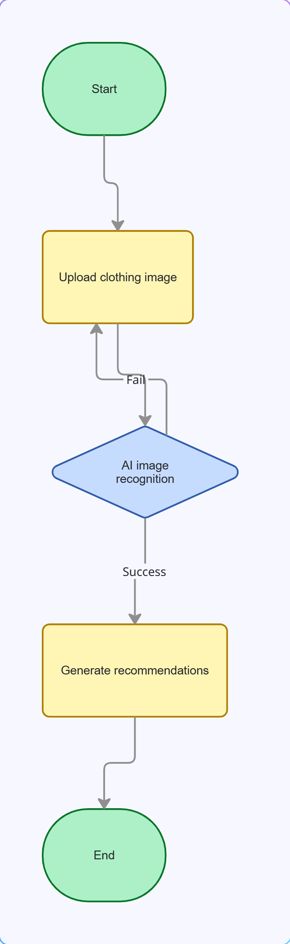

Fig 4.3.3 Activity Diagram of the AI Vogue Result Process

4.4 Flowchart
The flowchart of AI VOGUE represents the complete step-by-step workflow of how a user interacts with the platform and how the system processes each request. It visually outlines the path starting from the user’s first action and ending with the final output delivered by the system.
The process begins when the user opens the application or website. The system first c user is logged in or not.
If not logged in, the user is directed to the Login/Registration page.
If logged in, the user is taken to the home dashboard where they can choose different features like Revibe, TwinFit, Rental Store, or AI Chatbot.

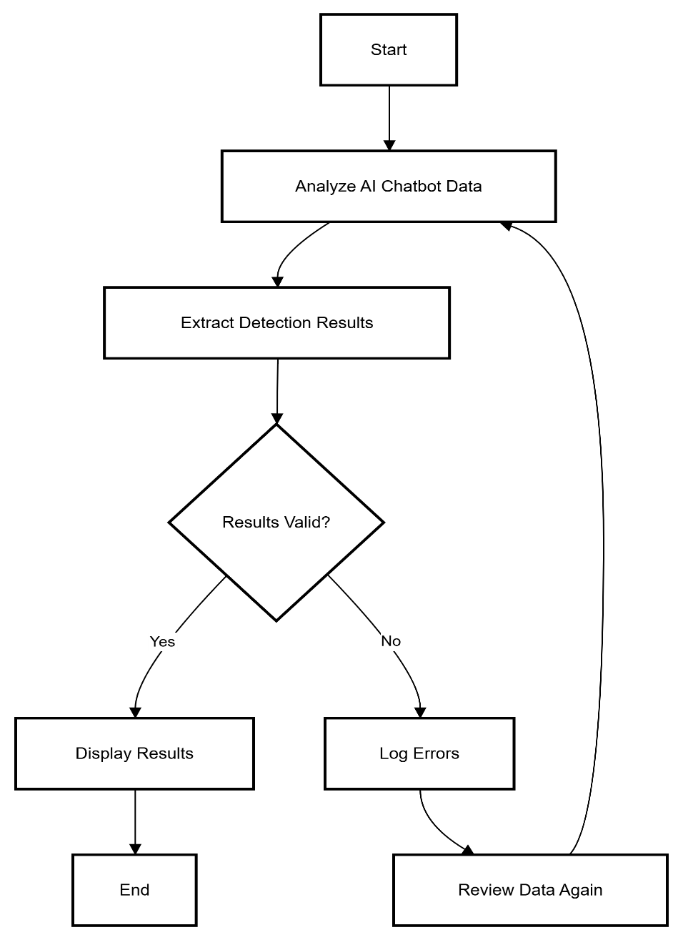

Fig 4.4 AI vogue Flowchart

Chapter 5 | Requirements

5.1 Hardware Requirements
- CPU: A multi-core processor such as Intel i5/i7 or AMD Ryzen 5/7 is recommended to handle webpage rendering, avatar generation, product loading, and backend operations. A stronger CPU ensures smoother performance across all AI Vogue modules.
- GPU: A dedicated GPU (NVIDIA GTX 1050 or higher) helps in rendering 2D avatars, image previews, and any visual AI enhancements. It accelerates graphics-heavy tasks, improving the overall user experience.
- RAM: A minimum of 8GB RAM is required, while 16GB is ideal for handling large images, UI animations, and multi-page operations (Thrift Store, Rental Store, Avatar Page). Higher RAM prevents lag during heavy usage.
- Storage: At least 50GB SSD storage is recommended for storing assets such as fashion images, avatar models, website resources, and temporary cache files. SSD ensures fast loading and smooth page transitions.
- Display: A Full HD (1080p) display provides clear and accurate visuals for fashion items, UI elements, and avatars. Higher resolution helps users see product details more effectively.
- Camera (Optional): If AI Vogue includes virtual try-on or face/body scanning, a 720p/1080p camera is needed. Higher resolution improves the accuracy of avatar creation.
- Network: A stable and fast internet connection is required for loading high-quality product images, syncing user data, sending notifications, and managing seller-customer interactions.
- Power Supply: A reliable power source ensures continuous operation of the platform, especially when hosting backend services. For critical environments, using a UPS prevents downtime and data loss

Software Requirements

1.Operating System:
Windows 10/11, macOS, or Linux for smooth development, deployment, and user operations. These systems support modern browsers, frameworks, and backend technologies required by AI Vogue.

2.Frontend Technologies:
HTML5, CSS3, and JavaScript for building the user interface. Frameworks like React.js or Vue.js improve performance, responsiveness, and modular design of pages like Thrift Store, Rental Store, and Avatar Try-On.

3.Backend Technologies:

A server-side environment such as Node.js, Django, or Flask to handle authentication, product management, database operations, notifications, and API integrations.

4. Database:
MySQL, MongoDB, or PostgreSQL is needed to store user profiles, product details, seller data, orders, rental history, and avatar configurations. A scalable database ensures smooth multi-user access.

5.API Integration
REST APIs or GraphQL for communication between frontend, backend, authentication systems, and notification services.

6.Web Browser
Modern browsers such as Chrome, Edge, or Firefox to support animations, media rendering, and dynamic UI components required by AI Vogue.

5.2.1 Operating System
The Operating System (OS) plays an important role in the overall functioning of the AI VOGUE platform. It acts as the foundational software layer that manages hardware resources, executes application components, and ensures smooth communication between different modules of the system. Since AI VOGUE involves AI processing, image handling, database operations, and web services, the OS helps maintain stability, security, and efficient performance throughout the workflow.
On the development side, the OS provides the environment required to run essential tools such as Python, Node.js, databases like MySQL or MongoDB, deep learning frameworks (TensorFlow/PyTorch), and local servers. It manages memory, CPU usage, file storage, and GPU access during tasks such as image preprocessing and AI model inference. This ensures that heavy computations like object detection, feature extraction, and model training run without system crashes or resource conflicts.
During deployment, the OS hosts the backend server, APIs, and AI engine on cloud or local machines. It handles request scheduling, process management, network configurations, and system security. Whether AI VOGUE is deployed on Windows, Linux, or a cloud-based OS environment, the operating system ensures that all services—from authentication to product matching—run in a coordinated and reliable manner.
Thus, the operating system forms the backbone of the AI VOGUE platform by providing the necessary environment for development, execution, resource management, and deployment of the application.

5.2.2 Python
Python plays a crucial role in the AI VOGUE platform, specifically for developing the Artificial Intelligence and Machine Learning components. It is widely used because of its simplicity, powerful libraries, and strong support for image processing and deep learning tasks. In AI VOGUE, Python is used to build the AI engine that performs object detection, clothing classification, feature extraction, pattern recognition, and similarity matching.With the help of popular Python libraries such as TensorFlow, PyTorch, OpenCV, scikit-learn, and NumPy, the system is able to analyze uploaded images, detect fashion items, identify colors and textures, and generate meaningful predictions. Python scripts handle the preprocessing of images, convert them into machine-readable formats, and feed them into trained deep learning models for accurate results.Python can also be used for backend microservices where AI logic is exposed through APIs (commonly built using Flask or FastAPI). These APIs communicate with the main application to provide outputs like predicted categories, similar product suggestions, virtual try-on mapping, and resale price estimation.
Overall, Python acts as the core language powering the intelligence of AI VOGUE, making the system capable of delivering smart recommendations, efficient detection, and seamless AI-driven fashion assistance.

Functional Requirements
1)User Authentication & Profile Management
- The system must allow users to register using email or phone number.
- Users must be able to log in, log out, and reset passwords.
- The system must maintain user profiles with saved preferences and history.

2)Image Upload & Input Processing
- Users must be able to upload images of clothing items.
- The system should accept multiple image formats such as JPG, PNG, and JPEG.
- The platform must validate, compress, and preprocess images before analysis.

3)AI-Based Object Detection
- The system must detect the presence of clothing items in an uploaded image.
- The AI model should identify features such as:
  - Clothing category (e.g., shirt, kurta, jeans)
  - Color
  - Pattern
  - Texture
  - Gender category
- The system must extract relevant features for classification and similarity search.

4) Classification & Feature Extraction
- The system must classify the clothing item into predefined categories.
- It should extract deep features for matching similar items.
- The AI engine must generate descriptive detection results for the user.

5) Recommendation System
- Based on detected features, the system must suggest similar or matching clothing items.
- The platform should provide style suggestions and outfit recommendations.

6)Revibe (Thrift / Resale Module)
- Users must be able to list used clothing for resale.
- The AI system must estimate product quality and generate a suggested price range.
- The platform must allow buyers to view, search, and purchase second-hand items.

7)TwinFit (Virtual Try-On)
- The system must allow users to try clothes virtually using AI-based fitting.
- The platform should detect body shape / measurements (if required).
- The try-on module must render the selected clothing on the user’s image.

8)Rental Store Module
- Users must browse and rent designer or occasional wear.
- The system must categorize items as rental-specific outfits (wedding, partywear, etc.).
- The platform must manage availability, booking, and rental confirmation.

9)AI Chatbot
- The chatbot must assist users with queries about:
  - Product search
  - Style suggestions
  - Revibe listings
  - Rentals
  - Try-on module

5.4 Non-Functional Requirements
1. Performance Requirements
- The system should process and display AI detection results within 2–5 seconds.
- The application must handle multiple simultaneous user requests smoothly.
- Product search and filtering should return results within 1–2 seconds.
- High-resolution images must be processed without system lag or crashes.

2. Usability Requirements
- The user interface must be simple, intuitive, and easy to navigate.
- Users should be able to upload images with minimal steps.
- The virtual try-on and Revibe features must be user-friendly and accessible to non-technical users.
- The system should support both mobile and desktop usage.

3. Reliability Requirements
- The system must provide consistent AI results with high accuracy.
- The platform should run without unexpected crashes or errors.
- Data must remain accessible even if part of the system fails.
- AI model predictions should remain stable across repeated inputs.

4. Security Requirements
- User login and personal data must be protected through authentication.
- Passwords should be encrypted and securely stored.
- Uploaded images must be handled securely and not exposed to unauthorized users.
- Payment and rental modules must comply with secure transaction protocols.

5. Scalability Requirements
- The AI Vogue Platform should be able to scale to support thousands of users.
- AI model performance should not degrade as the number of users increases.
- The database should handle large volumes of product, image, and user data.
- The AI Vogue Platform should be able to handle revibe, Rental, Ai Chatbot , AR.

Libraries and Modules
The AI VOGUE platform uses a combination of AI/ML libraries, web development frameworks, image processing tools, and database modules. These libraries help build the object detection system, virtual try-on feature, recommendation engine, and the overall platform backend.
5.4.1. Frontend Libraries / Modules

Used for UI development.

HTML, CSS, JavaScript – User interface design.

React.js – For building dynamic frontend pages.

Bootstrap / Tailwind CSS – For responsive UI.

5.4.2. Database Module

1.Used for storing user data, product listings, detection results, and images.

2.MongoDB (NoSQL database for flexibility)

3.MySQL (Structured relational database)

4.Firebase (Cloud database for authentication + storage)

5.4.3. Backend Frameworks

1.Used to create the server and expose AI results via APIs.

2.Flask – Lightweight web framework used to build AI microservices.

3.FastAPI – Fast modern API framework for handling image upload endpoints.

4.Node.js (Express.js) – If backend logic is done in JavaScript.

Chapter 6

Implementation
The implementation of the real-time object detection system using YOLO (You Only Look Once) and Text-to-Speech (TTS) involves a structured approach that integrates hardware, software, and algorithms. Below is an outline of the key implementation steps:

6.1 Implementation

Project overview & components
The AI Vogue project is an intelligent fashion-tech system designed to identify clothing items from images, recommend similar products, allow virtual try-on, and support rental or resale operations through dedicated modules like Revibe, Prism AI, and Rental Store. The system begins by taking an input image and applying object detection to recognize garments such as T-shirts, jeans, kurtas, jackets, or footwear. Once the items are detected, the system extracts meaningful features and embeddings from each garment, capturing details like color, fabric texture, pattern, and overall style. These extracted features help the system match the clothing item with the closest possible products in the database, enabling accurate recommendations and personalized fashion suggestions. The project also includes an AI Chatbot that supports natural user interaction by helping users search for items, ask fashion queries, and receive product guidance.

2.Data & Annotation
Images of clothing, categories, bounding boxes, segmentation masks. In AI Vogue, data and annotation play a crucial role in training the AI models that recognize and classify fashion items. The dataset consists of images of clothing such as T-shirts, jeans, dresses, accessories, and footwear. Each image is labeled with categories (e.g., “T-shirt,” “Hoodie,” “Kurta,” “Sneakers”) to help the model understand different fashion types.
To improve accuracy, annotations also include bounding boxes, which mark the exact region of the clothing item within the image. In more advanced cases, segmentation masks are used, which outline the precise shape and edges of the clothing. These detailed annotations help the AI model perform tasks like object detection, virtual try-on, trend analysis, and visual search with high accuracy.

3.Virtual try-on (TwinFit)
The Virtual Try-On feature in AI Vogue, also known as the TwinFit module, allows users to visualize how different outfits would look on them without physically wearing the clothes. This component uses a combination of pose detection, human segmentation, and garment warping techniques to create a realistic try-on experience. First, the system takes the user's uploaded image and identifies key body points such as shoulders, waist, hips, and arms using pose estimation algorithms.

4. Rental store flow
- Product listing with availability calendar.
- Rental request: start_date, end_date, size, pickup/drop options.
- Pricing rules, deposits, penalties.
- Backend: a DB table rentals to track state; implement notifications/emails.
- Return processing and quality check workflows.

5. Revibe Module in AI Vogue (Explanation)
The Revibe module in AI Vogue is a dedicated platform for buying and selling pre-owned, refurbished, or upcycled clothing items. Its purpose is to promote sustainable fashion by giving unused clothes a second life instead of letting them go to waste. Revibe allows users to upload images of their old garments, and the AI system automatically detects the type of clothing, extracts features like style, color, and brand, and generates a clean product listing for potential buyers.

6.AI Chatbot in AI Vogue
The AI Chatbot in AI Vogue is an intelligent virtual assistant designed to help users interact with the platform more easily and naturally. It allows users to ask questions about clothing items, search for styles, get outfit recommendations, track orders, and receive fashion suggestions through simple conversational messages. The chatbot uses Natural Language Processing (NLP) to understand user queries, identify the intention behind the message, and provide the most relevant response. It is also integrated with AI Vogue’s detection system, product database, and recommendation engine, allowing it to retrieve matching clothes, show similar items, and guide users to the Revibe, TwinFit, or Rental Store modules.

Chapter 7

Testing
The AI Vogue homepage was tested to ensure the main title, tagline, and action buttons load correctly and maintain proper alignment. The sidebar navigation was checked for smooth opening/closing and verified that each menu item redirects to the correct page. Responsiveness testing confirmed that the layout adapts well on desktop and mobile screens. Functional checks ensured that all buttons, icons, and links work without errors. Overall, the interface performs smoothly with no UI or navigation issues detected.

7.1 Functionality Testing
1. User Interface (UI) Testing
- Verified that the homepage elements such as AI VOGUE title, tagline, and buttons (Explore AI Fashion, Try TwinFit) are displayed correctly.
- Checked color consistency, text alignment, fonts, spacing, and overall layout to ensure a premium visual experience.
- Ensured that the background gradient loads properly on different display sizes.
- Navigation Menu (Sidebar) Testing
- Tested the right-side off-canvas sidebar to ensure it opens and closes smoothly.
- Verified all menu items such as Vogue Vision, Revibe, Creative Threads, MirrorX, Prism AI, Style Lease, TwinFit, About, Contact are correctly visible.
- Checked that each menu option links to the correct HTML page (e.g., creative-threads.html).
- Ensured that the close icon (X) functions properly and hides the sidebar.

- Exploration AI fashionTesting
- Verified that the Explore AI Fashion and Try TwinFit buttons are clickable and redirect correctly.
- Checked if the menu icons at the sidebar bottom (profile and login icons) respond properly when clicked.
- Ensured external links and internal page navigation work without errors.
- Verified all menu items such as Vogue Vision, Revibe, Creative Threads, MirrorX, Prism AI, Style Lease, TwinFit, About, Contact are correctly visible.
- Validates correct input–output behavior, ensuring the system returns the right results for user actions (e.g., selecting size, uploading image).
- Ensures buttons, links, and UI components respond properly without errors or unexpected behavior.
- Verifies backend processes, like object detection, pose estimation, and item retrieval, work accurately.
- Confirms integrations (database, APIs, AR module, camera access) function smoothly and provide consistent outputs.

Chapter 8  8.1  1. AI Vogue Parts | Results
When no object is detected, the system outputs a message as remains silent. The frame is displayed without any bounding boxes or labels, ensuring no false positives. The system continues monitoring and processing the video feed, ready to detect objects when they appear.
2.Virtual Try-On (TwinFit) testing

Functional tests

POST user image + garment_id → /tryon returns an image (or URL).

Validate image is non-empty and correct dimensions.

3.Chatbot (NLP & Retrieval) testing

Build test suite per intent (search, rent, buy, FAQ).

Sample intents:

Search: “show me red kurtas”

Rent: “rent a jacket from Dec 5 to Dec 7”

Order status: “where is my order #1234?”

4.Security & privacy testing

Checks

Upload limits (max size, types).

Path traversal and injection on file APIs.

Authentication & authorization for protected endpoints.

Data retention: verify image deletion endpoint works.

5.AR Testing
- Check if the AR camera opens correctly.
- Verify framing guidelines (show full upper body).
- Check focus, exposure, and clarity.

8.2 AI VOGUE with Side Navigation Menu

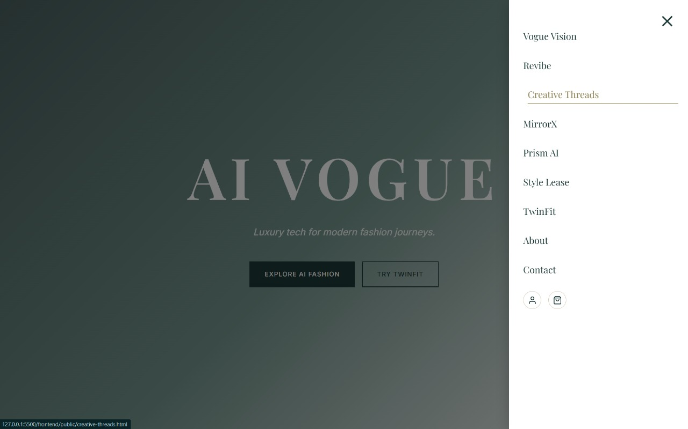
Fig : AI Vogue Sidebar Navigation Menu

  - AI Vogue to Explore Fashion
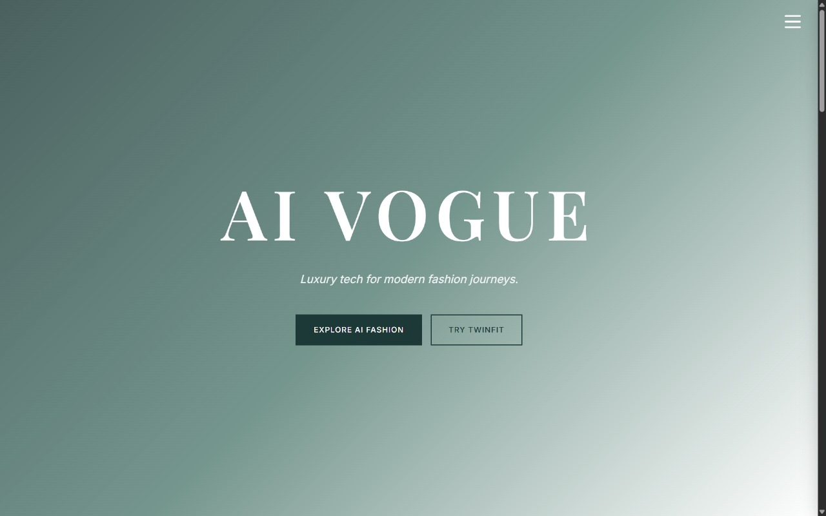

  - AI Vogue Collections

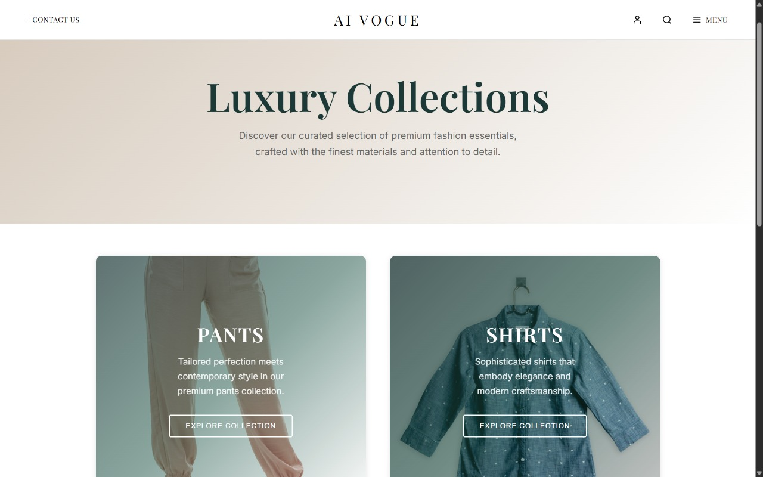

AI Vogue Luxury Collections represent a premium category within the platform where high-end fashion, advanced technology, and intelligent styling come together. This section curates exclusive designer outfits, luxury apparel, accessories, and premium fashion pieces that are enhanced through AI-driven personalization. Each collection is curated using AI algorithms that analyze trends, fabric quality, color palettes, and user preferences to recommend the most refined and stylish options.

AI Vogue Men’s Vintage

AI Vogue, the Men’s Vintage Collection is curated using AI to identify authentic retro patterns, fabric types, and style trends from past eras. Users can explore vintage-inspired looks, try them on virtually, and receive personalized recommendations that match their body fit and fashion preferences. This collection celebrates nostalgia, craftsmanship, and uniqueness, offering men a timeless and stylish wardrobe inspired by the classics.

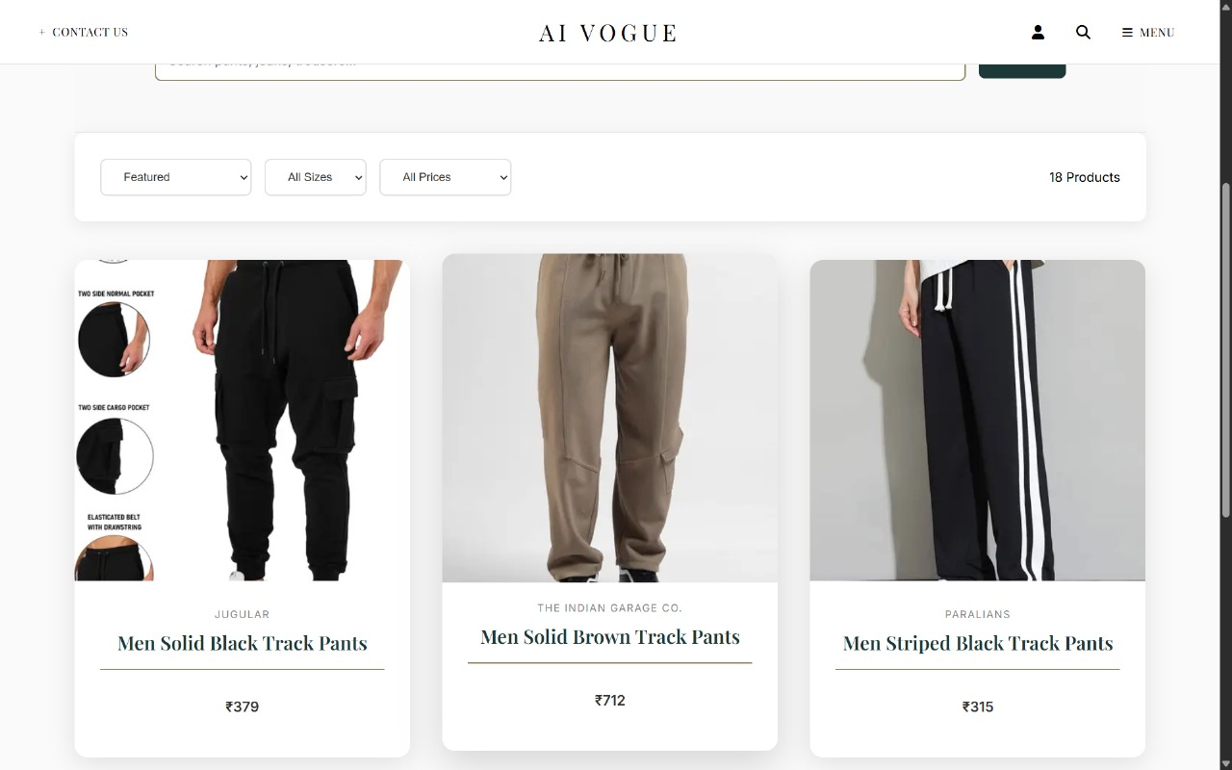
Fig 8.4 AI Vogue Men’s vintage

8.6. AI Vogue Shirt Print

Uses AI-based design generation to create custom T-shirt prints based on user input (text, style, patterns, colors).

Allows users to upload their own artwork or choose from templates generated by the system.

Provides virtual try-on so customers can preview how the printed design looks on a 2D/3D T-shirt model.

Uses image processing & design rendering to adjust print size, alignment, and color accuracy.

Enables personalized T-shirt recommendations based on style preferences and trending designs.

Offers print-ready file output (PNG, SVG) for real printing vendors.

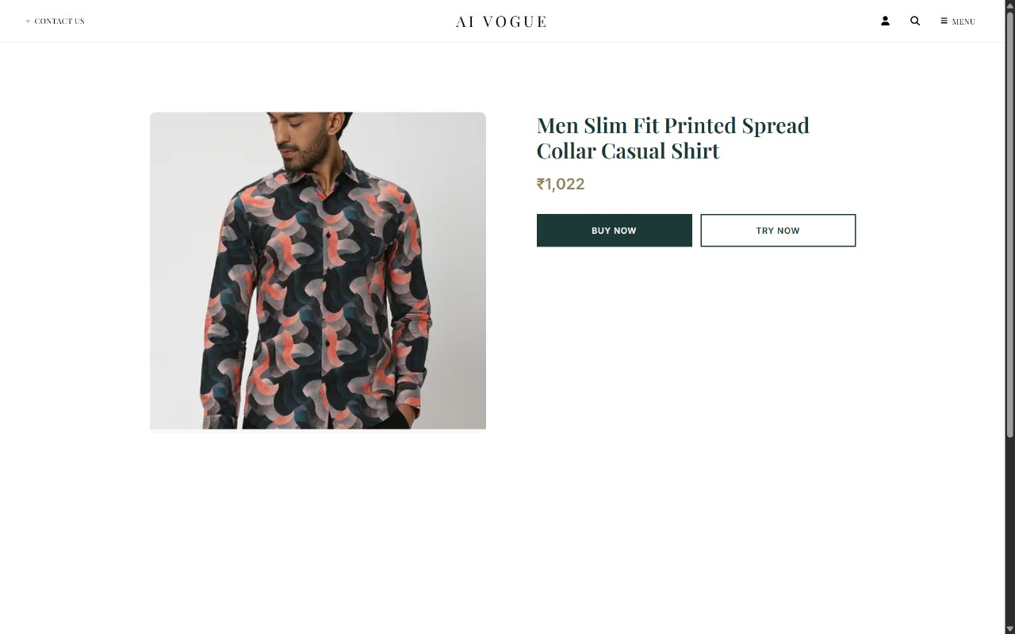
Fig 8.6 AI Vogue
8.7 Thrift Store
Thrift stores sell second-hand clothing and household items at affordable prices.they promote sustainable fashion by encouraging reuse and reducing textile waste.Items are usually donated, allowing stores to offer low-cost products.many thrift stores support charity or community programs through their earnings.shoppers can find unique, vintage, and branded items at lower prices.thrift stores help reduce environmental impact by minimizing discarded clothing.they attract customers looking for budget-friendly and eco-friendly shopping options.Some modern thrift stores use online platforms to sell pre-owned items.
AI Vogue successfully bridges the gap between fashion and technology by integrating advanced features like Thrift Store browsing, Rental Services, and 2D Avatar Try-On into a single unified platform. The system enhances the shopping experience by offering personalized recommendations, virtual outfit visualization, and sustainable fashion choices.
Many thrift stores support charity or community programs through their earnings.Shoppers can find unique, vintage, and branded items at lower prices.Thrift stores help reduce environmental impact by minimizing discarded clothing.They attract customers looking for budget-friendly and eco-friendly shopping options.

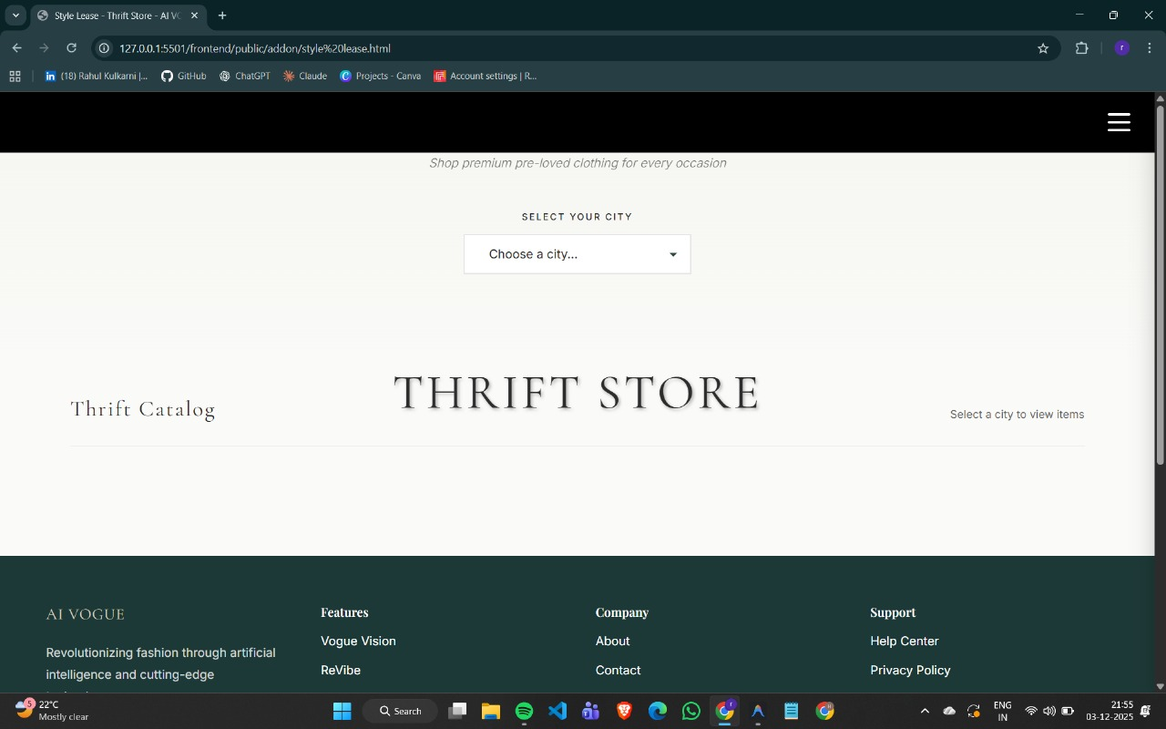
Fig. 8.7 Thrift Store
Thrift stores sell second-hand clothing and household items at affordable prices.they promote sustainable fashion by encouraging reuse and reducing textile waste.Items are usually donated, allowing stores to offer low-cost products.many thrift stores support charity or community programs through their earnings.shoppers can find unique, vintage, and branded items at lower prices.thrift stores help reduce environmental impact by minimizing discarded clothing.they attract customers looking for budget-friendly and eco-friendly shopping options.Some modern thrift stores use online platforms to sell pre-owned items.
8.7.1 Pants Collection
Pants Collection in thrift store is a modern lifestyle and wellness brand focused on creating uplifting experiences through innovative products and community-driven initiatives. The platform emphasizes self-care, positivity, and emotional well-being by offering curated content, motivational resources, and thoughtfully designed items. Revibe aims to inspire individuals to stay connected, recharge mentally, and build healthy habits in their daily lives. By blending creativity, technology, and wellness principles, Revibe encourages people to rediscover joy, reduce stress, and maintain a balanced lifestyle.
Pants Collection in Thrift store is an emerging brand focused on creating meaningful engagement and delivering high-quality experiences to its users. The company emphasizes innovation, style, and customer satisfaction, ensuring that every product reflects the latest trends while maintaining reliability. Revibe aims to build a strong connection with its audience by offering value-driven solutions, consistent service, and a modern approach to branding. With a commitment to continuous improvement, it strives to become a trusted name that users can rely on. The brand also promotes creativity, sustainability, and fresh ideas that resonate with today’s generation, making Revibe a growing symbol of energy, renewal, and progressive thinking.

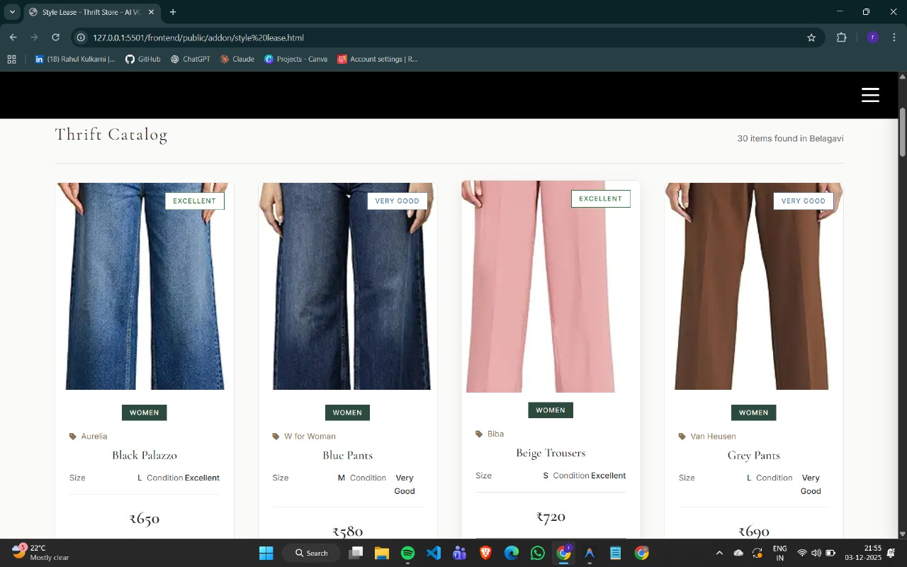
Fig. 8.7.1 Pants Collection
8.8 Revibe
Revibe is a modern lifestyle and wellness brand focused on creating uplifting experiences through innovative products and community-driven initiatives. The platform emphasizes self- care, positivity, and emotional well-being by offering curated content, motivational resources, and thoughtfully designed items. Revibe aims to inspire individuals to stay connected, recharge mentally, and build healthy habits in their daily lives. By blending creativity, technology, and wellness principles, Revibe encourages people to rediscover joy, reduce stress, and maintain a balanced lifestyle.


Fig 8.8 Revibe
8.8.1 Revibe Collections
Revibe is an emerging brand focused on creating meaningful engagement and delivering high-quality experiences to its users. The company emphasizes innovation, style, and customer satisfaction, ensuring that every product reflects the latest trends while maintaining reliability. 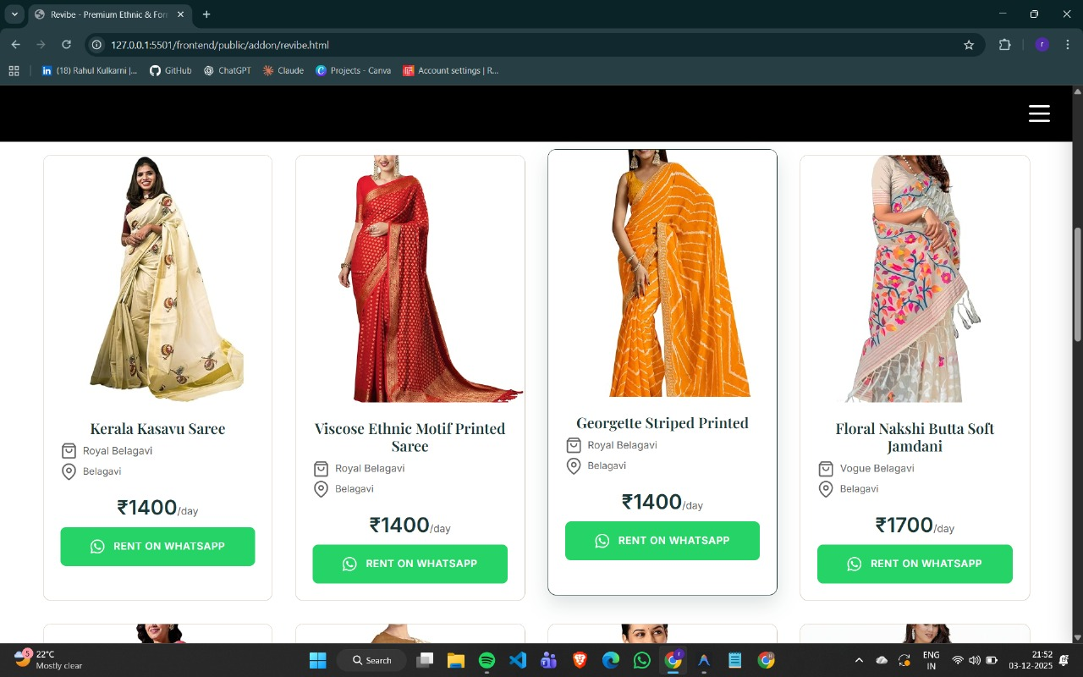
Fig 8.8.1 Revibe Collections
8.8.2 Custom Fashion Designer
Revibe is an innovative platform built to bring new life to pre-owned products by promoting sustainability and conscious consumption. It connects users who want to sell their gently-used items with buyers looking for affordable and quality alternatives. Revibe ensures that every product listed meets quality standards, creating a trustworthy eco-friendly marketplace. By encouraging reuse instead of disposal, Revibe helps reduce waste and supports a circular economy where resources are used efficiently and responsibly.

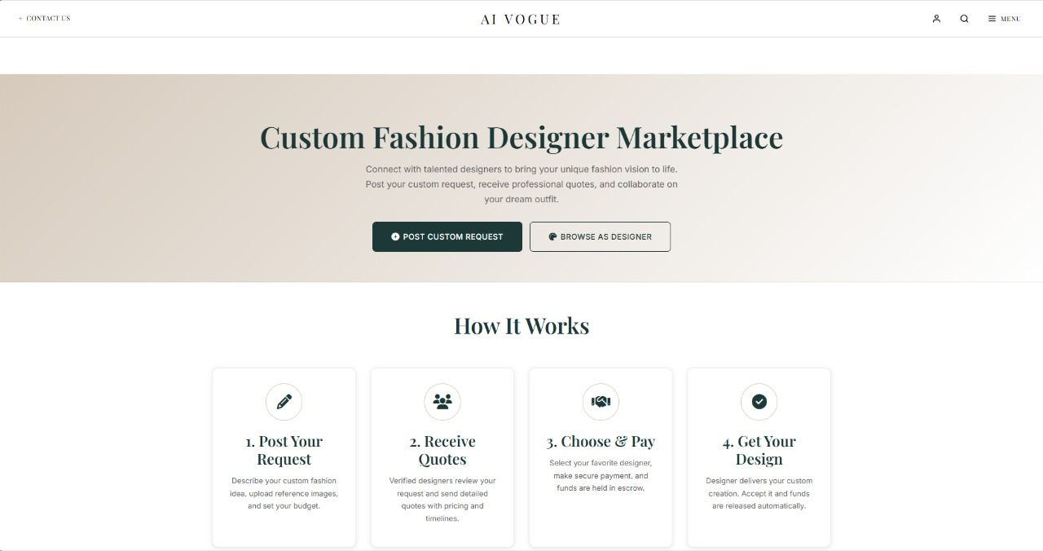
Fig 8.8.2 Custom Fashion Designer Designer
8.9 Prism AI
AI Prism is an intelligent analytical framework that breaks down complex data into clear, structured insights using multiple layers of artificial intelligence. It acts like a prism that takes in raw, unorganized information and transforms it into meaningful patterns, predictions, and recommendations. By combining machine learning, natural language processing, and automated reasoning, AI Prism helps businesses understand trends, optimize decision-making, and improve operational efficiency. Its modular approach ensures high accuracy, adaptability, and scalability across industries. It acts like a prism that takes in raw, unorganized information and transforms it into meaningful patterns, predictions, and recommendations. By combining machine learning, natural language processing, and automated reasoning, AI Prism helps businesses understand trends. By combining machine learning, natural language processing, and automated reasoning.

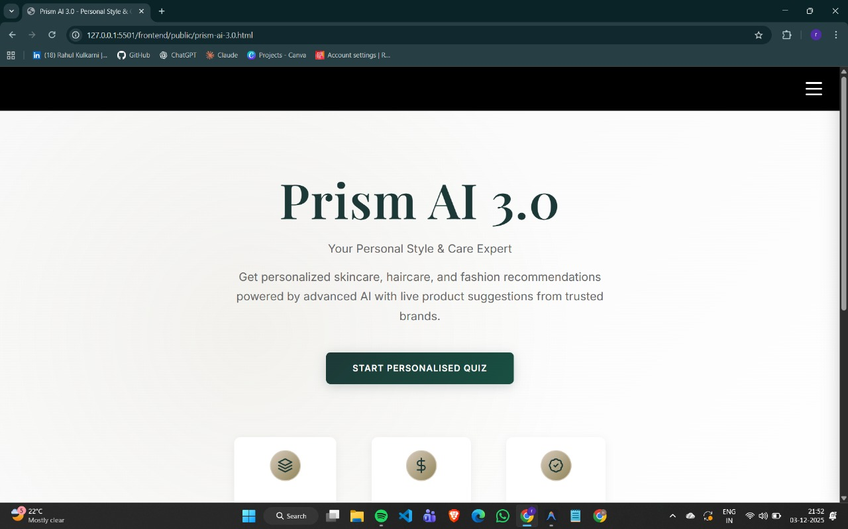
Fig 8.9 Prism AI
8.10 Profile Page : A profile page serves as the central hub for a user’s identity on a platform. It typically displays essential information such as the user’s name, profile picture, contact details, and a brief bio, allowing others to quickly understand who the user is. The page often includes editable fields so users can update their personal information, password, or preferences as needed. It may also showcase recent activities, posts, or transactions, along with social connections like friends, followers, or linked accounts. Additional features can include privacy and security settings, customization options, achievements or badges, and analytics to track engagement, all aimed at providing a personalized, secure, and interactive user experience.
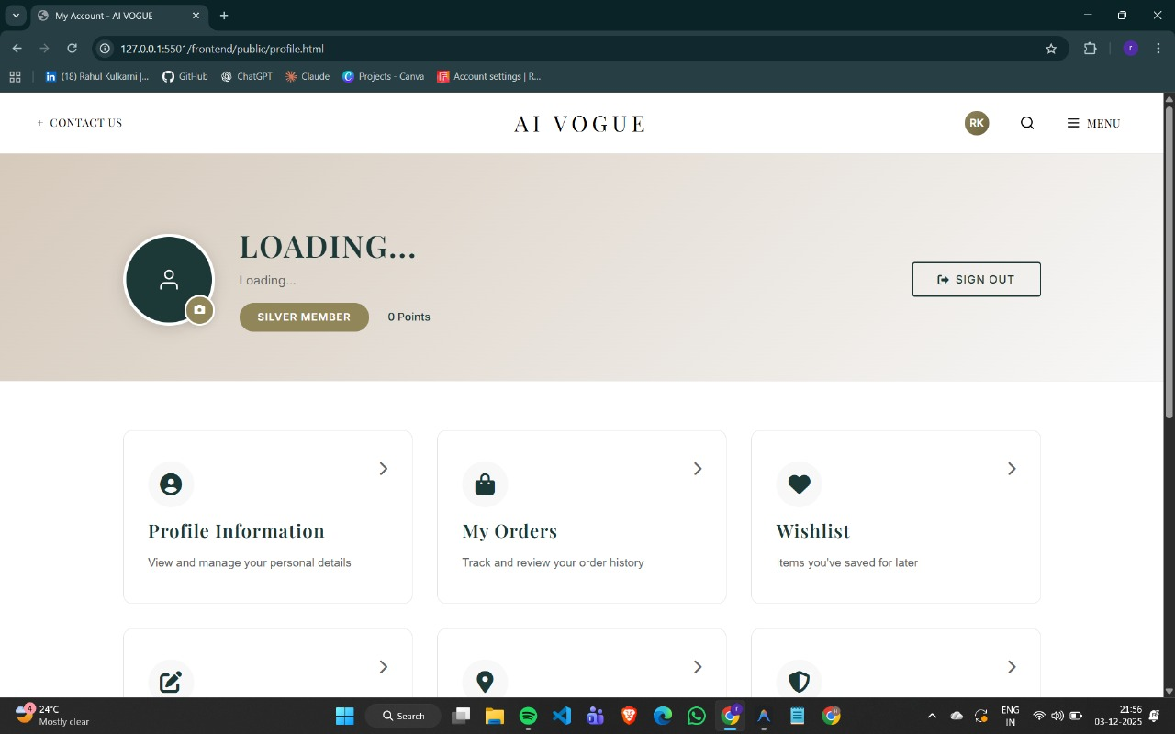
Fig 8.10 Profile Page

Chapter 9

Conclusion

AI Vogue is a modern, AI-driven fashion platform that combines Thrift Store shopping, Rental Services, and 2D Avatar Try-On to create a seamless and interactive user experience. By integrating smart technologies such as image processing, recommendation systems, and virtual try-on features, the platform enhances customer engagement and simplifies fashion decision-making. It supports sustainable shopping through thrifting and renting while offering personalized styling options. Overall, AI Vogue provides an innovative, efficient, and user-friendly solution that bridges technology with fashion, making the shopping process smarter, faster, and more enjoyable.
AI Vogue successfully bridges the gap between fashion and technology by integrating advanced features like Thrift Store browsing, Rental Services, and 2D Avatar Try-On into a single unified platform. The system enhances the shopping experience by offering personalized recommendations, virtual outfit visualization, and sustainable fashion choices. Through AI-based image processing, product detection, and user-friendly interfaces, AI Vogue makes fashion discovery more accurate, interactive, and engaging. The combination of strong backend architecture, efficient data handling, and smart UI design ensures smooth performance for both customers and sellers. Overall, AI Vogue stands as an innovative fashion-tech solution that promotes sustainability, improves decision-making, and delivers a modern digital shopping experience.
AI Vogue not only transforms how users shop but also redefines the digital fashion ecosystem by merging creativity, sustainability, and intelligence. With features like virtual try-on, personalized styling, and curated thrift collections, the platform empowers users to make confident fashion choices without physical trials. Its AI-driven modules ensure that every recommendation aligns with user preferences, body type, and current trends. By promoting eco-friendly practices such as renting and upcycling, AI Vogue encourages responsible consumption while still delivering a premium and immersive fashion experience.

References

[1] M. Zhou, R. Hyder, Z. Xuan, and G. Qi, “Ultravatar: A realistic animatable 3d avatar diffusion model with authenticity guided textures,” in Proceedings of the IEEE/CVF Conference on Computer Vision and Pattern Recognition, pp. 1238–1248, 2024.

[2] X. Liu, Y.-W. Tai, and C.-K. Tang, “Multimodal generation of animatable 3d human models with avatarforge,” arXiv preprint arXiv:2503.08165, 2025.

[3] I. I. Agbanu, A. B. Mohammed, and O. R. Inikpi, “Effect of ai driven personalization on purchasing decisions and customer satisfaction in the fashion industry in nigeria,” Journal homepage: https://gjrpublication. com/gjrbm, vol. 4, no. 05, 2024.

[4] A. S. Verma, “The role of fashion social commerce in advancing sustainable practices in india,” NIFT JOURNAL OF FASHION, p. 87, 2023.

[5] S. Xu, L. Wu, W. Liao, and S. Fujimura, “Enhancing collaborative shop ping experience through interactive personalized avatars and shared gaze in a multi-user augmented reality environment,” International Journal of Human–Computer Interaction, pp. 1–22, 2024.

[6] M. Yuan, I. R. Khan, F. Farbiz, S. Yao, A. Niswar, and M.-H. Foo, “A mixed reality virtual clothes try-on system,” IEEE Transactions on Multimedia, vol. 15, no. 8, pp. 1958–1968, 2013.

[7] R. Shiba, A. Fadel, A. Elbashaar, K. Emad, and R. Elgohary, “Expand: Animmersive virtual try-on system with augmented reality,” International Integrated Intelligent Systems, vol. 2, no. 1, 2025.

[8] M. A. Raji, H. B. Olodo, T. T. Oke, W. A. Addy, O. C. Ofodile, and A. T. Oyewole, “E-commerce and consumer behavior: A review of ai-powered personalization and market trends. gsc advanced research and reviews, 18 (3), 066–077,” 2024

